Premium Processing Service
U.S. Citizenship and Immigration Services
Vermont Service Center
ATTN: I-129
30 Houghton Street
St. Albans, VT 05478

RE: Petition for a Nonimmigrant Worker (Form I-129)
Classification: L-1B
Petitioner: Synechron Inc.
Beneficiary: Vishal Ramesh BHARDWAJ

Dear Sir/Madam:

This letter is submitted in support of the Petition for a Nonimmigrant Worker (Form I-129) filed by Synechron, Inc. (hereinafter “Synechron”) on behalf of Mr. Vishal Ramesh Bhardwaj. We would like to employ Mr. Bhardwaj for a three-year period as an Assistant Manager – Software. Mr. Bhardwaj will use his specialized knowledge of Synechron’s proprietary tool, specifically Synechron’s SyneMobiSafe tool, to complete a project located at the site of our client, Asurion, at 1400 Fashion Island, Suite 450, San Mateo, CA 94404.

EMPLOYER AND QUALIFYING CORPORATE RELATIONSHIP

Synechron, Inc. (“Synechron”) is one of the fastest-growing digital, business consulting & technology services providers specialized in financial services. Founded in 2005, the company works with a number of Fortune 1000 companies including the world’s leading financial services companies such as Bank of New York, ABN AMRO, CA-CIB, Markel, Bloomberg, MSCI, AQR Capital, Asurion, Bank of America, JPMorgan Chase, HSBC, Deutsche Bank, and Wells Fargo. Synechron delivers these organizations specialist business consulting including strategy and advisory across regulation, data management, customer life cycle, and more. The company is also one of the leading systems integrators for trading technologies like Murex, Calypso and Summit and has deep technical expertise in QA and custom application development across financial services.

Uniquely, Synechron has invested heavily in innovation to open several Financial Innovation Labs (FinLabs) around the world where clients can come to experience and experiment with the latest technologies and innovations in an interactive lab environment. Through its digital arm, Synechron focuses on weaving digital strategy, user experience and design across the business.

Synechron has been on a steep growth trajectory and has now reached $405 million in annualized revenue (over $215 Million in the US), With 7,000+ professionals operating in 18 locations across the world, it has presence across USA (over 900 employees in the US), Canada, UK, France, The Netherlands, Switzerland, Luxembourg, Serbia, Hungary, Germany, Italy, UAE, Singapore, Hong Kong, Philippines, Japan, Australia and Development Centers in India.

To summarize, Synechron, Inc. is a subsidiary of Synechron Holdings, Inc. Synechron Technologies Private Limited India is also a subsidiary Synechron Holdings, Inc. Synechron Holdings, Inc. is a parent company to both, Synechron, Inc. and Synechron Technologies Private Limited. As a result, Synechron, Inc. and Synechron Technologies Private Limited are affiliates. Please see enclosed copies of the letters from the CFO of the company confirming the relationship between the parties. Please also see enclosed a copy of the Consolidated Financial Statements for Synechron, Inc. for the year ended March 31, 2016, March 31, 2015 and March 31, 2014 establishing the relationship between the parties.

PURPOSE OF TRANSFER

Through Synechron’s relationships with leading customers around the world, it was noticed that wireless carriers and subscribers were increasingly indicating a growing demand for security of their mobile devices, i.e., to protect not only their phones, but also the valuable data and content on the phones (along with strong technical support).

Nowadays, business grows dynamically as a digital enterprise and almost every industry conduct their operations using devices that were non-existent a few years ago. Mobile devices also add significant value to people and organizations through increased efficiency and productivity. The world around us is also digitally transforming in a way that is having significant impact on how people and enterprises operate and this is affecting the technology and systems that are designed and built to support them.

However, this era of mobility introduces new risks and challenges to the security of mobile devices and the data it contains. SyneMobiSafe enables secure mobility by providing comprehensive risk management across Android devices to protect against app, network, and device-based threats while providing visibility and control over data leakage.

Synechron requires a person with specialized knowledge of its proprietary tool, SyneMobiSafe, for design, development, enhancement, and implementation of SyneMobiSafe for Synechron’s engagements. Mr. Bhardwaj has specialized knowledge of Synechron’s SyneMobiSafe because he designed the foundations of the tool and its various modules. He has played a critical role in SyneMobiSafe engagements through his project work for Synechron in India, which required use of his specialized knowledge in SyneMobiSafe. Hence, we require him to be transferred to the United States to perform the responsibilities requiring his specialized SyneMobiSafe knowledge discussed below for Synechron in the U.S. Mr. Bhardwaj will also be engaged in providing training on SyneMobiSafe in the U.S.

INTRODUCTION TO SYNEMOBISAFE

SyneMobiSafe is Synechron’s complete mobile solution tool whose objective is to provide data management and advanced customer support features, such as backup and restoration of contact and content data; recovery options like locate, lock, wipe, and alarm; security options such as antivirus and malware detection; and advanced mobile technical support services. SyneMobiSafe can enhance the user experience and deliver exceptional value to subscribers by using state-of-the-art analytics to provide a one-stop shop for not only resolving device issues, but also assisting users on how to manage their content and become more productive with their digital devices.

SyneMobiSafe provides effective and instant mobile technical support through a streamlined and simplified approach to customer-agent interactions. This helps enterprises to extend productivity through an unmatched customer service. It also allows businesses to manage customer experience and operational efficiency by appointing users to the most proficient and unoccupied agent suitable for the interaction. This can be achieved by -
- Determining what steps to take, in what order, on what device given a very wide range of settings.
- Relying on someone with strong technical background with a complete know how and who can perform right actions.

SyneMobiSafe provides a mechanism that allows tech agents to perform certain actions enables them to access user's device remotely and operate it. Agents can also draw some basic shapes on the device screen indicating the users to navigate through the settings menu and guide them to solve and fix the issues they are facing. This not only ensures that the problem is resolved, but also saves a lot of user’s time spent on interacting with the customer agents.

Mobile devices are particularly susceptible to reverse-engineering attacks and threats at the application-level, data/storage-level, and web-level. It is imperative to have an application that provides built-in security controls self-defense mechanisms that account for such threats and the limitations of a device OS limitations. SyneMobiSafe considers all this and offers a multilayer protection including:
- Antivirus protection
- Detecting phishing and malware websites, it and alerts the user if they are trying to access it on mobile web browser
- Real-time protection, including intrusion prevention and alerts that an attack/threat is in progress.

Telemetry implementation is an updated approach to the transition of mobile applications and is the need of the day. Based on a deep understanding of telemetry options and careful data analysis, we have developed a telemetry architecture that enables SyneMobiSafe to process information around user metrics, application data, crash reports, and a lot of other statistics about the device. It also gives the ability to query big data and generate insights (from large scale user’s data), which is delivered to them via proper channels like notifications.

The following is a high-level architecture diagram of SyneMobiSafe, its module architecture, and its workflow:

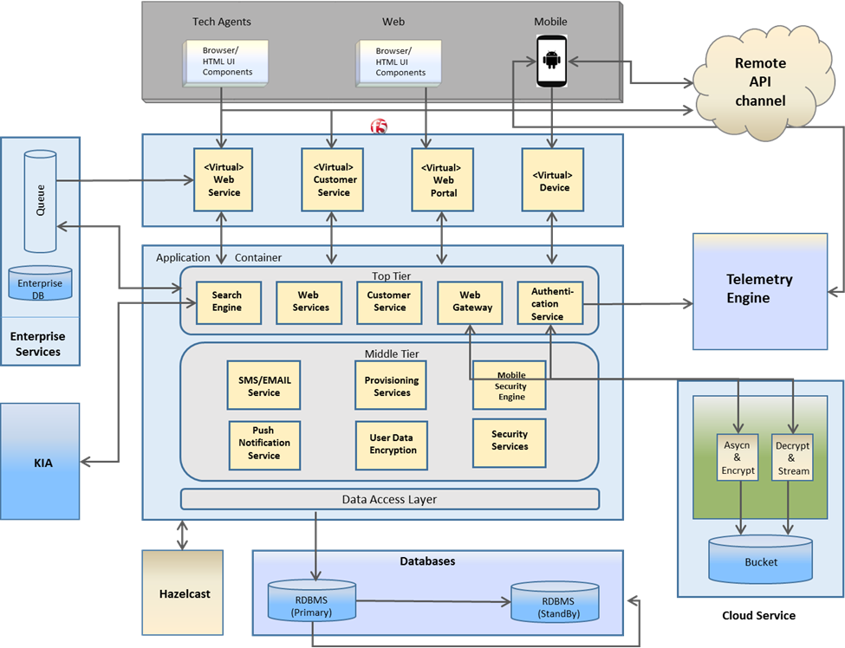

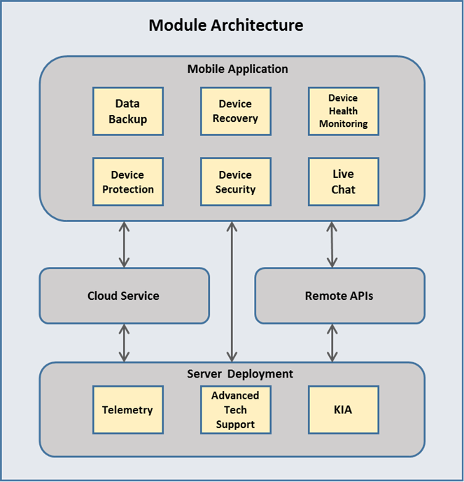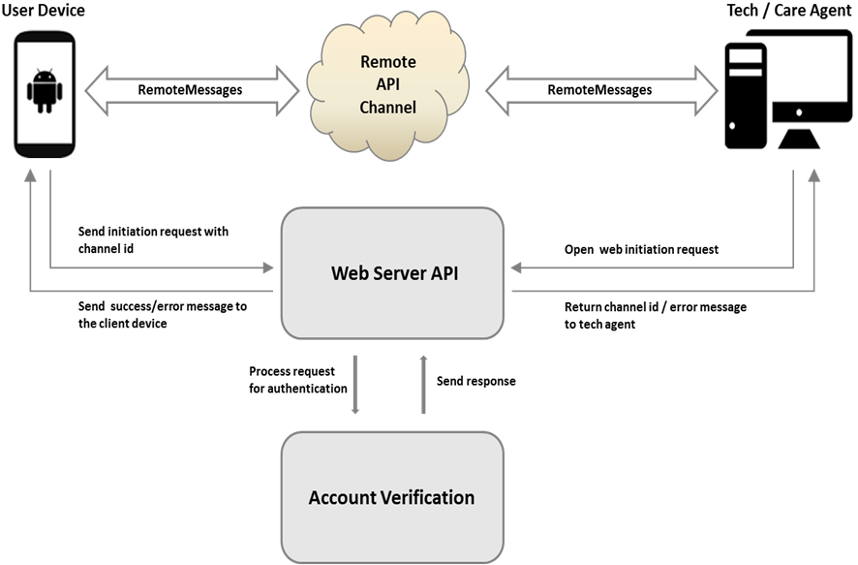
SyneMobiSafe is highly complex and consists of various modules. The following are the main modules of SyneMobiSafe. Please refer to the enclosed whitepaper for further details:

Module 1: Data Backup
This tool provides a backup system that is smart enough to take back up of that data, which has not been backed up. There is a complete algorithm that ensures cross-checking of numbers of file and types of files on the cloud and on the device, storage space, network restrictions, OS settings, and other user-defined configurations, before initiating a backup. Apart from these stringent configurations, the tool ensures that data transfer occurs in a secure manner and offers enhanced security options including data encryption.

Module 2: Device Protection & Security
The application enables secure mobility by providing risk management across Android devices to protect against network, app, and device-based vulnerabilities while providing visibility and control over data breach. It includes a comprehensive suite that enables the users to leverage its capability to provide security against malware, viruses, phishing sites, Trojans, etc. It also has a feature that warns the users against a possible phishing or malware website, if they are visiting any URL on the device browser.

Module 3: Device Recovery
Recovering a device is another integral aspect for a complete mobile solution as it enables the users to have full control of their device even if it's not with them (in case of theft or misplaced). This functionality consists of features such as Locate, Alarm, Lock, and Wipe.

Module 4: Device Health Monitoring
One of the most important things that always keeps a user engaged in an application is how it lets you know how healthy your device is. SyneMobiSafe enables users to scan through apps and data storage to gather information and run a complex algorithm to conclude the device and battery performance, which is helpful in identifying and resolving battery-related issues. It also indicates which apps are running high on memory, ones who use a lot of storage space and about the ones who consumes a lot of battery.

Module 5: Telemetry and Data Analysis
Mobile device telemetry data is a main information source for personalized engagement and it measures the real-time user experience. We use unique, big-data analytics to associate the anonymized device data with customer context to generate reports and enable personalized engagement that is timely, relevant, and actionable for the users. This is how data is collected (high-level) and sent across the servers. Telemetry data is uploaded from the device to a cloud-based analytics system. Collection and transmission of device telemetry are optimized to balance frequency of collection for obtaining up-to-date information with minimizing battery drain and data volume.

Module 6: Advanced Technical Support with Live Chat
SyneMobiSafe provides flexibility to the users to opt for instant tech support or go for live chat depending on the urgency and complexity of the issues they are facing. They can chat with care agents and communicate the problems they are struggling with or they can contact tech agents who can remotely access their device to fix issues and provide expert tech assistance and resolution.

Module 7: KIA (Know It All)
KIA is a knowledge-based value-added feature that enables SyneMobiSafe users to get tips and other articles with relevant information they might be seeking about their device or it may be related to any technical issue they are facing with their mobile phones. They can also perform a search for anything related to their device, ranging from security settings to Bluetooth or Wi-Fi connection issues and if available, a content-rich article will be provided to them containing step-by-step details.

UNIQUENESS AND BUSINESS IMPACT OF SYNEMOBISAFE

SyneMobiSafe comes as an all-in-one package to provide a cutting-edge mobile solution offering unique capabilities and broad ranging functionalities to its end users. It not only helps in securing users' personal content on their devices but provide advanced troubleshooting options too. The overall product initiative is to create a compelling application which is an integration of cloud services, device security and protection, device recovery, health monitoring and advance technical support services and deliver an all-in-one mobile solution offer. In addition, SyneMobiSafe will enhance mobile experience and satisfaction and provide value-added services for the end users.

With its robust analytics, rules engine, and services, SyneMobiSafe is differentiated from other competitors and enables any enterprise to be established as a reputed partner for their customers. The combination of all the functionalities and services makes it an excellent product that is inimitable and uses latest technology to provide value to its users.

SyneMobiSafe can furnish multiple business opportunities and can be seamlessly integrated with enterprises dealing into mobility. These can be carrier operators, or big mobile insurance providers who can equip their customers with this application (hard bundled to their mobiles) that can provide a comprehensive mobile solution for their needs and at the same time, be a cost-efficient approach to address business potential and enable business growth. The following are potential business advantages that can be achieved by implementing SyneMobiSafe:

  - Enhance existing customer relationships
- Improve customer experience with efficient and effective tech support
- Provide user-specific data analysis and timely action reports
- Improve availability and stability of business

  - Reduced incident handling cost
- Timely identifying and resolving issues brings down this resource consuming process significantly.

  - Enable growth opportunities
- Support subscriber growth with real-time user experience

  - Business Agility (detect and respond effectively and efficiently)
- Aims to enable understanding, inform decisions, and enhance business agility

POSITION OFFERED IN THE UNITED STATES

As Assistant Manager – Software, Mr. Vishal Bhardwaj will lead the efforts for this project and will design, development, enhancement, and implementation of Synechron’s SyneMobiSafe tool based on the inputs received. He will be responsible for creation, execution, and maintenance of SyneMobiSafe. In addition, the position is responsible for the complete setup and configuration of the entire system.

In performing his duties, Mr. Vishal Bhardwaj will utilize his specialized knowledge and understanding of the tool, its development standards, custom interfaces, modules, automated builds and the relationship between various components of Synechron’s SyneMobiSafe tool to perform impact analysis to better suit redesigning requirements of the tool. Specifically, Mr. Vishal Bhardwaj will perform the following duties and responsibilities:

U.S. Duty 1: SyneMobiSafe Architectural Design Analysis & Module Planning - 20% of daily work time

Specialized Knowledge: Mr. Vishal Bhardwaj will utilize his advanced level of specialized knowledge to make decisions related to the architectural redesign analysis for new changes and enhancements. This will be followed by module planning that would include plug-in of any new interfaces or components with the system, revamp of the existing components of the tool, addition of any new modules in the system, analysis of alternative solutions and possibilities, and any other changes for adapting the system to new requirements.
- Specifically, this will require him to perform architectural design analysis, design feasibility study and checks from the requirements provided by the technical analysts. For SyneMobiSafe tool implementation, he will utilize his specialized knowledge of its architecture to provide solutions, which may require component redesign or changes to some configurations. This involves identifying a list of complex business scenarios or importance of a functional area to be enhanced.
- Create a high-level plan to break down the whole development process into various modules and modules into components, which includes redesign of the entire system architecture, phase-wise development approach and deliverables, work flow creation, data modelling, data storage and object serialization. This further includes effort estimation in person days to develop selected modules, use cases, automate builds, timelines, tools, licensing & environments used, test data, etc.
- This duty will also require him to use his specialized knowledge to redesign and create a virtual environment to simulate real business scenarios. He will use his knowledge of SyneMobiSafe tool to generate the advanced tech support-related end-to-end functional test scenarios, test data, and its performance, to further expedite its simulation and accuracy with actual case of customer base.

U.S. Duty 2: SyneMobiSafe UI Design and New Branding - 30% of daily work time

Specialized Knowledge: Mr. Vishal Bhardwaj will utilize his advanced level of specialized knowledge of SyneMobiSafe tool to create and redesign the existing application modules which includes creation of the components of the modules. This requires specialized knowledge of each of the modules to manage changes related to components. Mr. Vishal Bhardwaj would also be engaged in creation and optimization of dynamic business workflows for SyneMobiSafe. To perform such analysis and optimize business flows requires specialized knowledge in tools’ workflows. Specifically, he will perform the following tasks:
- Perform impact analysis and feasibility study followed by design for changes to this tool and work with the development team on redesigning.
- Design required use case and workflows for SyneMobiSafe’s architecture and redesign modules as per business requirements.
- Redesign and enhance the whole user interface, fine tune existing naming standards, and optimized UI properties.
- Implement version control to keep track of the ongoing development process and better design of relational database architecture

U.S. Duty 3: SyneMobiSafe Tool Setup, configuration, and Implement (Telemetry reporting mechanism, advanced tech support, and value add services) - 40% of daily work time

Specialized Knowledge: Mr. Vishal Bhardwaj will utilize his specialized knowledge in SyneMobiSafe to setup and configure SyneMobiSafe into the production environment and optimize workflows and implement all the modules available in the tool. He will be taking care of the end-to-end tool development, so that the newly implemented system meets business requirements and objectives. Mr. Vishal Bhardwaj will also be engaged in verifying the reports generated by automated tests, analysing the failures, and finding the solutions for such failures. Mr. Vishal Bhardwaj will be utilizing his specialized knowledge of SyneMobiSafe tool for load balancer that involves providing the precise system resources that will be sufficient to serve the end users with expected load criteria. He will also take care of design and creation of database objects like stored procedures, Db Engine, etc. The following are some of his responsibilities:
- Setup of Load Balancer systems and server configurations for production and other non-production environments.
- Setup of required machines, devices and environment for automated test execution.
- Redesign error handling, logger, and debugger components and configure utilities and plugins to enhance SyneMobiSafe tool as per the requirements.
- Create checklist for all required plug-ins needed for automatic generation of the build for the new system, basic network and configuration for hosting the server.
- Analyse the changes and enhancements required to setup telemetry server and its implementation.
- Redesign the advance technical support module as per the business rules and policies.
- Redesign the knowledge based module resulting into generated articles

U.S. Duty 4: Training - 10% of daily work time

Mr. Vishal Bhardwaj will provide trainings to the following team members in the use of the redesigned tool, and will divide his time equally among them:
- Mr. Sagar Ekbote, who is employed by Synechron. He will be trained on the following modules of the SyneMobiSafe tool – Data Backup, Device Protection and Security, Device Recovery, Device Health Monitoring along with its automated test cases, Advanced Technical Support with Live Chat, Telemetry and Data Analysis and KIA (knowledge based value add module).

Mr. Bhardwaj will have one (1) team member in the U.S., but because he lacks specialized knowledge of SyneMobiSafe, he will only be able to perform the following duties: develop custom views and UI components as per the redesigning, prepare test data considering performance test cases and its validation, use custom tools to perform automation testing, perform peer reviews, code walk-throughs and validation.

Even though Mr. Vishal Bhardwaj will be assigned by Synechron to work on a project at Asurion’s facility in San Mateo, California, he will continue to remain an employee of Synechron, and will be supervised by Synechron. Mr. Vishal Bhardwaj will report directly to his onsite manager, Mr. Nilesh Dharmadhikari, whose title is Senior Manager – Software, who will communicate with Mr. Vishal Bhardwaj daily through emails and calls. For his services, as Assistant Manager - Software, Mr. Bhardwaj will be paid an annual salary of $90,355.00.

THE BENEFICIARY’S QUALIFICATIONS

Mr. Vishal Bhardwaj is well qualified to perform the job duties and responsibilities of the position of Assistant Manager - Software, by virtue of his advanced level of specialized knowledge in our SyneMobiSafe tool and applying that specialized knowledge for over one year to project work with our company, Synechron Technologies Private Limited in India. Mr. Bhardwaj received a Bachelor of Engineering in Computer Science & Engineering from Rajiv Gandhi Proudyogiki Vishwavidyalaya, Bhopal in India. He joined Synechron Technologies Private Limited in August 2012 as a Sr. Associate – Software. Mr. Bhardwaj was promoted to Lead – Software in February 2015, and to Assistant Manager – Software in April 2016. Through his employment for Synechron in India, Mr. Bhardwaj has been employed in a specialized knowledge capacity, involving redesigning Synechron’s SyneMobiSafe.

Mr. Bhardwaj gained his advanced level of specialized knowledge of Synechron’s SyneMobiSafe by designing its major foundations for Synechron from February 2015 to February 2016. His duties for SyneMobiSafe’s module design can be broken down as follows:

- Data Backup: Vishal Bhardwaj designed this module as an automatic and real time cloud data backup solution. To achieve this, he wrote the complex algorithm to ensure that as soon as new images or contacts are added to the device, a system-level event is triggered and the files/contacts are uploaded to the remote server on a background thread. He has developed the algorithm in such a way that before the actual upload starts, all the files' metadata are gathered and an exchange happens between the server and the device to check if similar files are already backed up (saved or deleted). Along with this, he also managed the user configurable settings, backup frequency, network and OS-level restrictions that makes the logic more complex before uploading the files to the cloud server. (20% of work time)

- Device Protection & Security: Mr. Bhardwaj performed the technical design and implementation of this module. He designed this module to track the malicious files copied to the device along with the capability to detect side loaded apps. As the application runs, a service is initiated to scan the complete file storage and analyze the signature (binary makeup) of each file for match or partial match against a database of known viruses and trojans. If a match is found, the user is notified and can choose to delete the file or ignore it. Integration of custom signed certificate chain is also implemented to prevent man-in-middle attacks, so when the application is launched, it first checks the validity of the SSL handshake between the server and progresses only after successful authentication. A service is also implemented as a background thread to detect if any phishing website is being accessed by the user on the device browser. It matches the URL entered against a list of known threats and warns the user by showing proper message on the UI. (10% of work time)

- Device Recovery: Mr. Bhardwaj developed the Device Recovery module, which has a vital role in locating and managing mobile devices in case of theft or misplace. He developed this module based on push notifications and the functionality is a successful implementation based on an effective communication between mobile device, backend, and cloud server. He wrote components that track the cloud server for any incoming messages. An API call is triggered to the backend server to fetch the next course of action and based on that it performs necessary operations. Depending on the actions (lock/sound/wipe), necessary classes and methods are invoked to sound an alarm on the device, or to lock it, or to wipe the data. For locate action, GPS-related classes are used and location services are enabled to collect the device's current location coordinates and sends across to the backend via API calls. (10% of work time)

- Device Health Monitoring: Mr. Bhardwaj designed this module for device monitoring to enable users to keep track of applications and other services slowing down the performance of the device. The user is provided with the options to perform speed, storage, and battery scan as a part of user interface and once any of these actions are performed, a service is executed and an algorithm kicks in to collect information for the installed apps. For speed, the algorithm detects number of processes running on the device and consuming a lot of memory and in the process slowing it down. Similarly, records are generated for applications consuming large storage space and absorbing a lot of battery. Once this information is available, user is notified with a list of applications hampering the device performance. (10% of work time)

- Telemetry and Data Analysis: Mr. Bhardwaj designed this module as a one-stop solution for effective data analysis. The functionality is written in such a way that a service component keeps running in the background to gather user data and a job is scheduled to transfer it to the remote server after every specific interval. The user’s device settings and application configuration (like report size, number, and transmit frequency) have also been considered for the working of the module. On the backend, depending upon the criticality (i.e. low memory storage, app crashes, etc.) of the input data and business rules, user insights, i.e. standard HTML templates are generated and stored on the server and a notification is sent to the device along with its content URL. On the device, once the message is received, the URL is fetched from the notification response and the report is displayed on the web view. (20% of work time)

- Advanced Technical Support with Live Chat: Mr. Bhardwaj designed this module to provide a customer-centric experience and a real-time problem solving mechanism to the end users. As the application runs, a service call is made to initiate a request on server for authentication with a unique id and after successful authentication, same id is used for initiating a request for access on the remote channel. The remote API channel is designed in such a way that tech agents can view device screens to give and maintain a seamless user experience. If agents are not available, callback interfaces are also implemented that communicates the reason for agent’s unavailability to the users and proper error messages are displayed to the user. For the chat feature, push notification is implemented, and all the necessary components like cloud server service and broadcast receiver are integrated beforehand, so as soon a message is received, the response is parsed and a notification is created using an intent and displayed on the UI panel. (20% of work time)

- KIA (Know It All): Mr. Bhardwaj designed the KIA module, which is a knowledge-based module that enables users to get device-related articles and tips on the go along with custom searches. The module is implemented in such a way that it runs a job to gather the device data like make, model, and OS version across its users’ base, and with a complex algorithm, generate custom articles/tips (HTML content) specific to the users' device and sends it as a notification containing the article URL. For search functionality, the keyword is sent as service request and looked-up into articles repository and if available, content/article URL is delivered to the user as a response. If not, depending upon certain requirements like number of times that keyword is searched, an article is generated and stored on the repo so that it can be useful for later searches. (10% of work time)

Compare and Contrast Duties with his India team:
Mr. Vishal Bhardwaj’s India team consisted of Prateek Patel, Prajakta Naringe, Yoganand Chillale and Pavan Kulhalli. Their duties that were insufficient to impart any advanced knowledge of Synechron’s SyneMobiSafe, was as follows:

- Design test scenarios and validation (20% of their daily work time)
- Design User Interface for the application (20% of their daily work time)
- Automation test data creation (10% of their daily work time)
- Test integrated components of the application (30% of their daily work time)
- Checking for memory leaks and code validation (10% of their daily work time)
- Debugging of application (10% of their daily work time)

These duties do not reflect any advance knowledge on Synechron’s SyneMobiSafe.

Mr. Bhardwaj has been applying his advanced knowledge of our SyneMobiSafe since March 2016 till present while working on the following projects in India.

Project 1: Protection App (Asurion), March 2016 - Till Date

- Mr. Vishal Bhardwaj applied his specialized knowledge of Synechron’s SyneMobiSafe and played a critical role in architectural enhancement of the SyneMobiSafe tool by providing a comprehensive mobile solution including security, protection, tech support, and other value-added services in mobile insurance domain. Mr. Bhardwaj redesigned the user interface of SyneMobiSafe to meet various functional and non-functional requirements. The enhancement of SyneMobiSafe tool also included simplification of user interface, consistent use of UI components, views and layouts, and strategic use of colors and icons for displaying alerts, notifications, and messages. He also used his in-depth knowledge of the tool for the environment setup, integration among the modules of the tool, and configuration of the same. (30% of his daily work time)

- Mr. Vishal Bhardwaj applied his specialized knowledge of Synechron’s SyneMobiSafe by redesigning and reviewing architectural-level templates of each module along with its technical feasibility. Mr. Bhardwaj also identified the compatibility challenges, initial design errors, and integrity factors for coherent development to make a cohesive SyneMobiSafe tool. Mr. Bhardwaj also focused on the enforcement of adhering to Synechron’s development guidelines to ensure proper implementation and integration of different functional modules of the tool. (40% of his daily work time).

- Mr. Vishal Bhardwaj used his specialized knowledge of Synechron’s SyneMobiSafe to identify critical business scenarios that were a road block for Synechron’s SyneMobiSafe tool and provided the solution architecture for technical support, telemetry, error handling, data storage, device protection, and its security (25% of his daily work time).

- Mr. Vishal Bhardwaj worked on creation of methods, Built-In functions, automated build generation, folder creation for version control and data back up, and the code compilation of the Protection Application during its initial development phase to minimize errors and ensure quality of the Protection Application. (5% of his daily work time) -Updated as discussed.

Mr. Vishal Bhardwaj relied solely on his advanced knowledge of Synechron’s SyneMobiSafe tool in performing these duties on this project.

Compare and Contrast His India Team’s Duties:
Mr. Vishal Bhardwaj’s India team consisted of Prateek Patel, Prajakta Naringe, Yoganand Chillale and Pavan Kulhalli. Their duties, which did not require or convey any advanced knowledge of Synechron’s SyneMobiSafe tool, were as follows:

- Created user interface and new branding (20% of their daily work time)
- Created various test scripts and perform peer reviews of test cases (20% of their daily work time)
- Created required test data and run already created integration test scripts. Prepared and published daily test report (10% of their daily work time)
- Performed dry test run on a regular basis after development and integration of each module and as per new changes as and when implemented. (30% of their daily work time)
- Performed code validation and used custom tools to check for any memory leaks throughout the application (10% of their daily work time)
- Performed debugging of the application to look for any potential crash and application breakdown (10% of their daily work time)

Mr. Vishal Bhardwaj’s salary in India has been 1172644 INR per annum, whereas the average salary for his classification is only 800181 INR per annum. This premium salary was due to his advanced knowledge of Synechron’s SyneMobiSafe tool. Further, due to his exceptional contributions regarding SyneMobiSafe for our company, Mr. Bhardwaj was nominated for Synechron’s Surpass Award for the period of January 2016 – March 2016.

Mr. Bhardwaj’s advanced knowledge of our SyneMobiSafe has enhanced Synechron’s productivity, competitiveness, image, and financial position in the marketplace

Mr. Bhardwaj has valuable experience in the implementation of Synechron’s SyneMoiSafe tool, as described above. Mr. Bhardwaj’s specialized knowledge has provided him with an in-depth knowledge and understanding of the tool’s proprietary design and development. This proprietary tool has played major role in developing Synechron's productivity and image due to its features such as real-time customer support, effective and timely data analysis, agility, modular and faster development and uniqueness.

Mr. Bhardwaj has valuable experience in the implementation of Synechron’s SyneMobiSafe, as described above, which has benefitted Synechron by developing a tool that is agile and highly performant and can cater to a wide customer base. The tool also helps Synechron to showcase its potential in mobility space.

DIFFERENTIATION BETWEEN GENERALIZED & SPECIALIZED KNOWLEDGE ON SYNEMOBISAFE

Synechron employees may gain generalized knowledge of SyneMobiSafe to provide basic services such as customer onboarding, customer support and other general services like troubleshooting the tool. Mr. Bhardwaj’s advanced knowledge consists of understanding of the tool’s proprietary design and development, which he gained through developing SyneMobiSafe’s major foundations. This advanced knowledge is necessary for the redesign, enhancement, and implementation of Synechron’s SyneMobiSafe.

Mr. Vishal Bhardwaj has in depth understanding of the tool and this is extremely important as this forms the base line for making decisions. Even single line in thousand lines of code may cause performance bottleneck and the same needs to be isolated through proper analysis and deep knowledge of the tool. Failure to do this would mean root cause of the performance is not identified and not fixed. This would pose huge risk since a system with such bottlenecks present would be unstable, prone to frequent crashes resulting in higher maintenance & interrupted services to end customers.

DIFFERENCE IN THE CORE TRAINING IMPARTED TO EMPLOYEES IN GENERAL AND SIMILAR INDUSTRY POSITIONS

Synechron employees may undergo core training focused primarily on technical areas such as JavaScript, Web Services and ASP.Net. They are also trained in soft skills such as Personality Development, Email Etiquette, Presentation Skills, and Team Management.

This core training does not provide the advanced level of knowledge that Mr. Bhardwaj possesses in SyneMobiSafe, which he obtained through designing the tool for Synechron. Core training is certainly insufficient to prepare one for Mr. Bhardwaj’s specialized knowledge responsibilities in his proposed U.S. position, which involves significant redesign of SyneMobiSafe.

As he developed SyneMobiSafe for Synechron, Mr. Bhardwaj holds special and advanced in-depth knowledge and understanding of and experience with the highly specialized and unique coding attributes of our SyneMobiSafe. This specialized knowledge and proprietary experience gained by Mr. Bhardwaj with our SyneMobiSafe tool is unique within our organization. This knowledge is not available to an individual who has not worked for the Synechron group of companies.

WHY A SUITABLE CANDIDATE CANNOT BE RESOURCED FROM THE LOCAL US LABOR MARKET

As explained elsewhere in this letter, Mr. Bhardwaj acquired advanced knowledge of our SyneMobiSafe from February 2015 to February 2016 outside the US. He subsequently spent a full year applying that advanced knowledge to project work outside the US.

It would be very difficult to find a candidate who possesses Mr. Bhardwaj’s specialized knowledge on Synechron’s SyneMobiSafe, which is critical for successful project engagement. Due to the high degree of complexity involved in SyneMobiSafe, it would take any experienced lead or analyst an extensive period of time to obtain Mr. Bhardwaj’s level of specialized knowledge of Synechron’s SyneMobiSafe. Further, this specialized knowledge and proprietary experience gained by Mr. Bhardwaj with our SyneMobiSafe is unique within our organization.

FINANCIAL IMPACT

Mr. Vishal Bhardwaj is a key member in Synechron’s SyneMobiSafe services, which is evident from the role he has played in the development and implementation of this framework. Unavailability of Mr. Bhardwaj to handle this project will result not only in a financial loss to Synechron, but will also reduce its competitiveness by not being able to fulfill its agreements.

It is not feasible to invest the time and resources to create more Synechron professionals with advanced knowledge in Synechron’s SyneMobiSafe prior to embarking on this project. This measure would cause our company serious economic inconvenience, in terms of salary and training personnel, and in extended delays to Synechron.

CONCLUSION

We believe we have shown that Mr. Bhardwaj’s advanced level of specialized knowledge of our proprietary product is vital for Synechron to perform its obligations under its agreement with Asurion. We believe we have established the qualifying corporate relationship and the specialized knowledge required for the Beneficiary to be classified as an L-1B nonimmigrant. At this time, we respectfully request that our L-1B petition on behalf of the Beneficiary be approved. Thank you for your consideration in this matter.

Sincerely,

SYNECHRON, INC.

Ravi Arya
Senior Manager-HR

